**Java Applet Theory and Life cycles**

Applet is a special type of program that is embedded in the webpage to generate the dynamic content. It runs inside the browser and works at client side.

***Advantage of Applet***

There are many advantages of applet. They are as follows:

* It works at client side so less response time.
* Secured
* It can be executed by browsers running under many plateforms, including Linux, Windows, Mac Os etc.

***Drawback of Applet***

* Plugin is required at client browser to execute applet.

***Hierarchy of Applet***

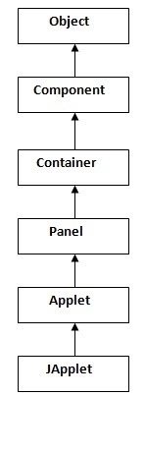

|  |
| --- |
| As displayed in the above diagram, Applet class extends Panel. Panel class extends Container which is the subclass of Component. |

***Lifecycle of Java Applet***

1. Applet is initialized.
2. Applet is started.
3. Applet is painted.
4. Applet is stopped.
5. Applet is destroyed.

***Lifecycle methods for Applet:***

The java.applet.Applet class 4 life cycle methods and java.awt.Component class provides 1 life cycle methods for an applet.

***java.applet.Applet class***

For creating any applet java.applet.Applet class must be inherited. It provides 4 life cycle methods of applet.

1. **public void init():** is used to initialized the Applet. It is invoked only once.
2. **public void start():** is invoked after the init() method or browser is maximized. It is used to start the Applet.
3. **public void stop():** is used to stop the Applet. It is invoked when Applet is stop or browser is minimized.
4. **public void destroy():** is used to destroy the Applet. It is invoked only once.

***java.awt.Component class***

The Component class provides 1 life cycle method of applet.

1. **public void paint(Graphics g):** is used to paint the Applet. It provides Graphics class object that can be used for drawing oval, rectangle, arc etc.

***Who is responsible to manage the life cycle of an applet?***

Java Plug-in software.

***How to run an Applet?***

There are two ways to run an applet

1. By html file.
2. By appletViewer tool (for testing purpose).

**APPLET EXAMPLE**

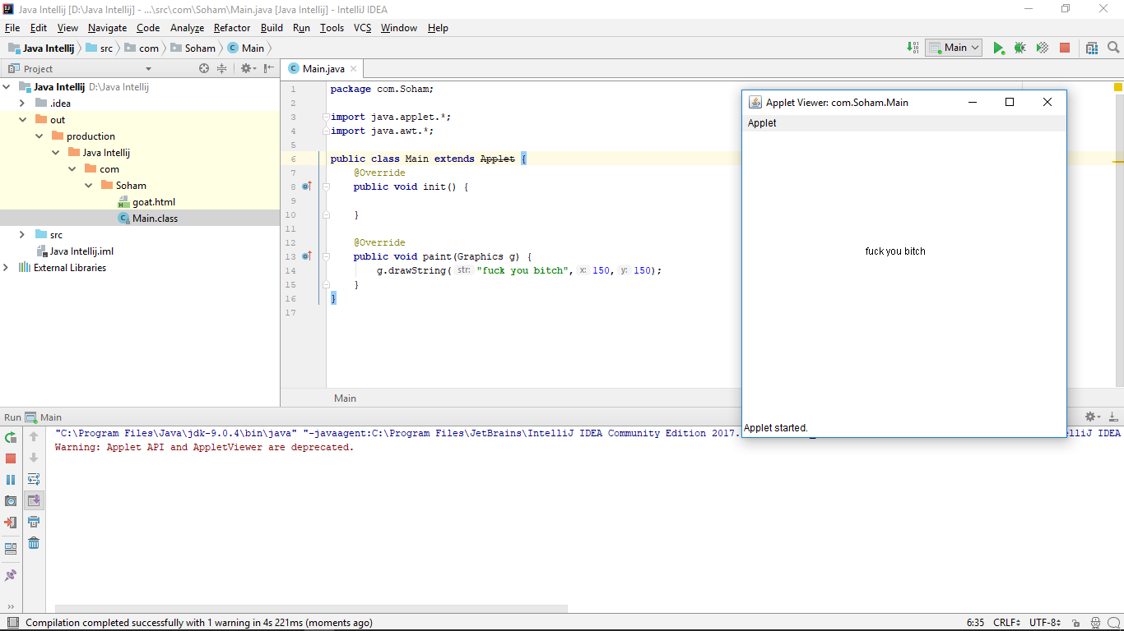

1. **init( ) :**The **init( )** method is the first method to be called. This is where you should initialize variables. This method is called **only once** during the run time of your applet.
2. **start( ) :**The **start( )** method is called after **init( )**. It is also called to restart an applet after it has been stopped. Note that **init( )**is called once i.e. when the first time an applet is loaded whereas **start( )** is called each time an applet’s HTML document is displayed onscreen. So, if a user leaves a web page and comes back, the applet resumes execution at **start( )**.
3. **paint( ) :**The **paint( )** method is called each time an AWT-based applet’s output must be redrawn. This situation can occur for several reasons. For example, the window in which the applet is running may be overwritten by another window and then uncovered. Or the applet window may be minimized and then restored.

**paint( )** is also called when the applet begins execution. Whatever the cause, whenever the applet must redraw its output, **paint( )**is called.

The **paint( )** method has one parameter of type [Graphics](https://docs.oracle.com/javase/7/docs/api/java/awt/Graphics.html). This parameter will contain the graphics context, which describes the graphics environment in which the applet is running. This context is used whenever output to the applet is required.

1. **stop( ) :**The **stop( )** method is called when a web browser leaves the HTML document containing the applet—when it goes to another page, for example. When **stop( )** is called, the applet is probably running. You should use **stop( )** to suspend threads that don’t need to run when the applet is not visible. You can restart them when **start( )** is called if the user returns to the page.
2. **destroy( ) :** The **destroy( )** method is called when the environment determines that your applet needs to be removed completely from memory. At this point, you should free up any resources the applet may be using. The **stop( )** method is always called before **destroy( )**.